Heads up! Social vigilance behaviour in urban American crows
Alex Popescu¹, Anne B. Clark², Taylor Kerr¹, Alex Wilder¹, Kiyoko M. Gotanda¹
¹ Brock University, Department of Biological Sciences
² Binghamton University, Department of Biological Sciences

Introduction
Urbanization is an ever-growing concern in behavioural ecology and is a driver of adaptive and non-adaptive changes in many species (Donihue and Lambert 2015). With global urbanization increasing, over two-thirds of the human population is predicted to be concentrated in urban areas by 2050 (UN Department of Economic and Social Affairs 2018). From enlarging existing cities to creating new ones altogether, huge swathes of natural landscapes are being converted to facilitate human occupation. This triggers several changes in the environment, including an increase in impermeable surfaces and human infrastructure, which can severely impact the survival and behaviour of many native species. This has resulted in a strong association between urbanization and the global decrease in biodiversity (Aronson et al. 2014).
While many species are negatively affected by urbanization, some species can tolerate or even benefit in urban areas. Species like the American crow (Corvus brachyrhynchos) have adapted to urban living and their abundance has increased with increasing urbanization (Benmazouz et al. 2021). Understanding how urban specialists like the American crow have adapted is an increasingly important field of research. Behavioural adaptations have allowed these species to use anthropogenic resources and deal with the challenges of urban living (Lowry et al. 2013; Isaksson 2018). Behavioural adaptations can include changes in foraging behaviour, such as preference for anthropogenic foods or foraging on sources of human refuse such as garbage cans and dumpsters. Adaptations of vigilance behaviours are also recorded, such as increased tolerance to human proximity and vehicular disturbances (Mukherjee et al. 2013; Isaksson 2018).
A common challenge in studying urban animal behaviour is the tendency to generalize comparisons between "urban" and "non-urban" populations, with few or no consideration given to the diverse environments within urban areas. Urban landscapes are not homogeneous, and cities have many different micro-environments of varying levels of urbanization. The many parks and green spaces in St. Catharines, Ontario, differ greatly from its commercial areas. These two examples, commercial and green areas, stand on two ends of the urbanization spectrum, and demonstrate sharp differences between areas within a city.
Green areas are typically quieter and greener areas in a city, where the increased presence of trees and wider patches of grass and vegetation offers urban species a comparatively more natural area to forage in. These spaces will have longer lines of sight, fewer and different types of disturbances, as well as a greater presence of more natural foods such as seeds and invertebrates. On the other hand, commercial areas are more disturbed and will have a greater presence of vehicles than in green spaces. Louder ambient noise levels, more impermeable surfaces and shorter lines of sight also characterize these environments. Finally, commercial areas can have an increased presence of human food sources such as litter and garbage and will harbor fewer natural food sources to forage on.
The many differences between these two environments can have considerable effects on how species behave within them. For example, communication in commercial areas can be disrupted by the higher ambient noise levels (Kern and Radford 2016), whereas this effect is lesser in the comparatively quieter green areas. This can have great effects on how species engage in social vigilance behaviours such as sentinel behaviour, where the effective and early communication of threats is paramount to the behaviour being advantageous. Sentinel behaviour is a coordinated social behaviour where an individual is constantly vigilant to monitor threats while others forage (Bednekoff 2015), and can be observed in many species including the American crow. Sentinel crows can often be seen perched in prominent, exposed positions to monitor threats, and make alarm calls to alert the group if dangers are detected. Foragers under the vigilance of the sentinel benefit from the sentinel’s coverage, resulting in an increase in biomass intake without increasing the risk of injury or mortality (Hollén et al. 2008).
In green areas, the longer lines of sight and lower ambient levels could make the behaviour more effective and increase forager reliance on the sentinel. Foraging for natural food items obscured within patches of vegetation is expected to take longer than foraging for human foods on impermeable surfaces. The presence of urban predators such as the red-tailed hawk (Buteo jamaicensis) could also increase the risk of predation (Morrison et al. 2016), increasing forager reliance on the sentinel (Ridley et al. 2010). In contrast, commercial areas are louder and more disturbed could see individuals rely less on the sentinel and adopt a more vigilance-oriented foraging strategy (Kern and Radford 2016). The increased availability and predictability of anthropogenic food sources that are usually concentrated (e.g. trash cans, litter) can also lead to changes in foraging strategy (Lowry et al. 2013), a reduction in resource competition (Łopucki et al. 2021), and high energetic levels in urban individuals (Auman et al. 2008).
The multitude of ways urbanization can affect social behaviours reinforces the need for further research on urbanized social species. Despite the growing interest in urban wildlife ecology, studies on the adaptation of social behaviours to urban living are limited. Sentinel behaviour is a complex social adaptation that can have far-reaching effects on group dynamics and foraging efficiency. By examining the effects of sentinel presence and generalized environment, we seek to gain insights into how adaptive social behaviours contribute to the success of this species in urban environments. With these findings, we could be able to determine how other social species capable of sentinel behaviour could respond to urbanization. In this study, we aimed to determine the effects of sentinel presence and the environment on the social foraging behaviour of urban American crows. We hypothesized that the presence of a sentinel and the foraging environment would affect the reliance of foragers on the sentinel, thereby affecting their alert and foraging behaviour of crows. We predicted in urban green spaces where the longer lines of sight and decreased ambient noise would increase the sentinel’s effectiveness, and crows would show decreased individual vigilance and increased reliance on the sentinel’s vigilance, leading to more efficient foraging compared to crows in commercial areas. In contrast, we predicted that crows foraging in commercial areas where the environment is highly variable and frequently disturbed, crows would have increased reliance on individual vigilance, with longer bouts of alert behaviour, and shorter bouts of foraging behaviour, resulting in decreased foraging efficiency.
Studying the behaviour of American crows in urban environments is therefore crucial for several reasons. Understanding how crows can alter their individual and social behaviours to better forage in urban landscapes can contribute to our understanding of urban adaptation of wildlife. By examining how crows respond to urban challenges such as increased ambient noise, impermeable surfaces, and increased frequency of disturbances, we can better comprehend how animals perceive their environment. Lastly, by studying changes in their social behaviours, we can better discern the contribution of social adaptation to the success of urbanized social species.

Methods

Site Selection
To find areas in which crows aggregate, we launched a community science initiative in the greater St. Catharines and Niagara region called Crowkemon Go (www.crowkemon.weebly.com) in spring 2022. Community members were invited to report the location of crow sightings to identify areas with a high likelihood of crow occurrences. In total, the community recorded 221 crow sightings using Crowkemon Go between January and May 2022. From April-May 2022, we visited potential observation sites and baited them with whole peanuts to attract crows and reinforce an association with food at these locations. We limited data collection to the summer months (June-September 2022). One site was sampled repeatedly (Fairview Park, 43°10'57.4"N 79°14'44.9"W; Figure 1). We also visited areas with many crow sightings for opportunistic sampling, as the presence of crows was not guaranteed at other potential recurrent sampling locations (Figure 1). Some opportunistic sampling locations were visited more than once or could be in proximity to previous sampling locations.
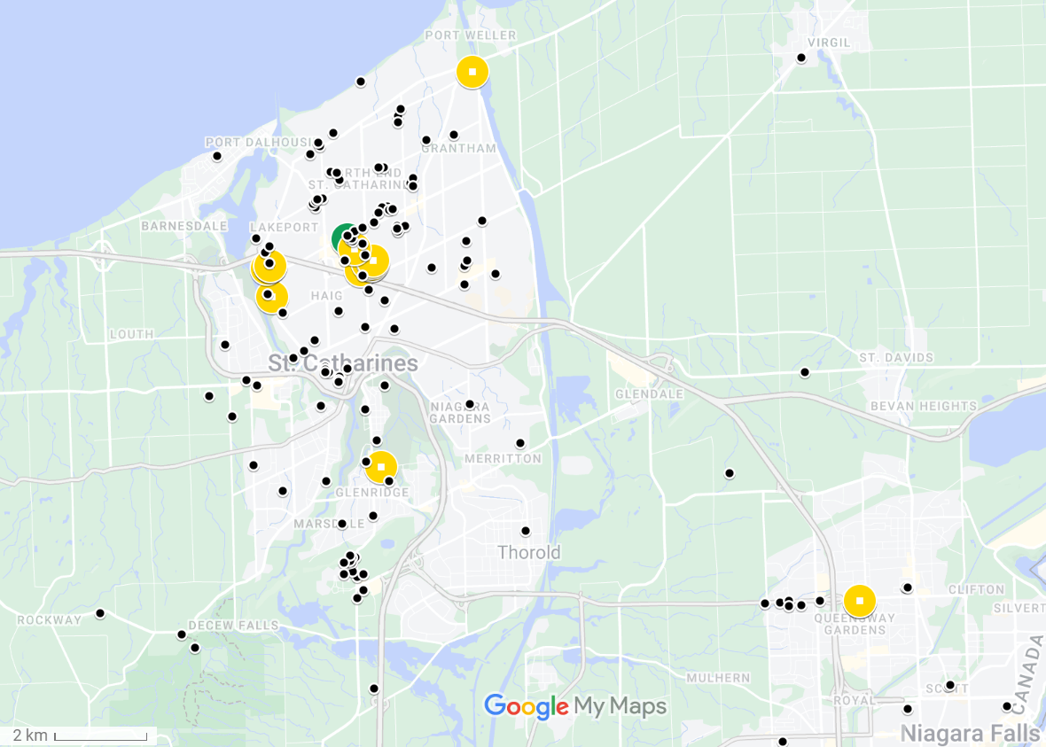
Figure 1: Map of observations from Crowkemon Go and sampling locations.
The black dots represent observations collected from Crowkemon Go, and the circular icons are sampling locations. The single recurrent site used is in green. Opportunistic sampling sites are in yellow. The focal area was limited to the St. Catharines & Niagara region. This map was created using Google My Maps.

Field observations
Data collection was performed during the 2-3 hours following sunrise (approx. 6-9 am EDT). No sampling was performed when it was raining or during adverse weather (e.g., thunderstorms or heatwave). Upon arriving at the recurrent sampling location, a Nikon D5300 camera with a 70-300mm Nikkor lens was set up on a tripod at a minimum of 15m away from a concrete pad (predetermined bait location). If crows were already foraging in the area, we would begin recording immediately and not bait the site because approaching could cause them to abandon the site. If the crows were not foraging (e.g. perched nearby), an observer approached and visibly dropped 30g of Cheez-Its. If crows were on-site, recording would start immediately, whereas if the crows were absent, a crow-caller would be used for 20 minutes (one 5 seconds call per minute, 5 mins on, 5 mins off for 20 minutes or until crows appeared) to attract them. We began recording when crows arrived and recorded up to a maximum of 20 minutes. The recording was stopped if the crows vacated the area for longer than 5 minutes and we remained in the area for 10 minutes post-departure in case the crows returned. If the crows returned within 5 minutes, we would resume the recording. For opportunistic sampling, we looked for crows using Crowkemon Go as a guide. If we found crows that were already foraging, we would set up in the same manner as for recurrent sampling and did not bait the site. Conversely, if the crows were not already foraging, we would bait the site as we did for recurrent sampling.
The presence of a sentinel, a group-member perched away from the foragers, was announced verbally by the observer during the recording. For each location, we classified the type of environment using St. Catharines municipal zoning maps, later generalized as either “commercial” or “green”. Disturbance frequency was calculated by dividing the number of disturbances by the duration of the recording. We identified disturbances as anything passing within 5m of the crows’ foraging area, including vehicles, pedestrians, and domestic and wild animals. The group size was binned into two categories: small ($≤$4) and large ($>$4).

Video Analysis
For video analyses, we used the Behavioral Observation Research Interactive Software (BORIS v.8.9.4) (Friard and Gamba 2016). We recorded each individual in frame separately, and we classified and individual’s behaviours as either “foraging” or “alert”. “Alert” behaviour was defined as an upright posture where the individual is scanning their surroundings, and “foraging” was when the individual was looking downward, either pecking at or looking for food on the ground. We recorded the duration of bouts (i.e. each instance) of each behaviour longer than 0.01 seconds. Movement behaviour was noted, but, since not all bouts of movement were filmed in their entirety, “moving” behaviour was excluded from these analyses. We then calculated the proportion of time spent performing each behaviour. An individual could have two observations if sentinel presence changed, as bouts were recorded separately for whether a sentinel was present or not.

Statistical Analysis
All statistical analyses were performed in the R environment (v.4.2.2; R Core Team, 2022). We first ran separate chi-squared tests to determine if the generalized environment, the group size, or the disturbance frequency affected the likelihood of sentinel presence. To determine the effects of generalized environment and sentinel presence on the proportion of time allocated to each behaviour (alert or foraging), we used the “lm()” function to fit separate linear models using behaviour type, sentinel presence, and generalized environment as predictors.
To determine the effects of generalized environment and the presence of a sentinel on the duration of bouts of all behaviours, we used the “rlmer()” function from the “robustlmm” package (Koller 2016) to fit a robust linear mixed model to the log-transformed duration of bouts with behaviour type, sentinel presence, generalized environment, group size, and bait presence as fixed factors, the disturbance frequency (number of disturbances per min.) as a fixed effect and the individual ID as a random effect. We included in these models the interaction between sentinel presence and generalized environment. We then fitted post-hoc robust linear mixed models on each behaviour to determine the effects of sentinel presence and generalized environment on each behaviour.

Results
Sentinel presence changed in 8 videos, and therefore, we made 19 observations with a sentinel present and 14 observations without a sentinel for a total of 33 observations. The generalized environment (χ² = 0.122, df = 1, p = 0.727), group size (χ² = 0.248, df = 1, p = 0.618), and the disturbance frequency (χ² = 2.033, df = 2, p = 0.362) did not significantly affect if a sentinel was present or not.

Proportion of time allocated to each behaviour
Crows allocated similar proportions of time to foraging and vigilance ($\hat{β}$ = 0.026, SE = 0.023, t = 1.160, p = 0.248; Figure 3.2, Table 3.1), and neither the presence of a sentinel ($\hat{β}$ = -0.034, SE = 0.023, t = -1.431, p = 0.154; Figure 3.2, Table 3.1) or the generalized environment ($\hat{β}$ = 0.034, SE = 0.023, t = 1.463, p = 0.146; Figure 3.2, Table 3.1) had an effect on the proportion of time allocated to either alert or foraging behaviour.
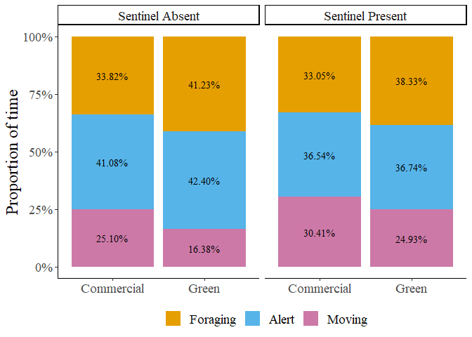
Figure 3.2: Proportion of time allocated to each behaviour by foragers in commercial and green areas.
Table 3.1: Effects of sentinel presence and generalized environment on the proportion of time allocated to each behaviour.
Predictors | Estimates | Std. Error | p-value
Intercept | 0.3658 | 0.0240 | <0.001
Behaviour | 0.0263 | 0.0226 | 0.248
Sentinel Presence | -0.0335 | 0.0234 | 0.154
Generalized Environment | 0.0336 | 0.0230 | 0.146
Observations | 154
R²/R² adjusted | 0.037/0.018

Duration of bouts of all behaviours
In total, 3897 bouts were recorded, of which 2110 bouts, or instances of each behaviour, were of “alert” behaviour, and 1787 bouts were of “foraging” behaviour. The average duration of bouts was 1.75 seconds. Bouts of alertness and foraging differed significantly ($\hat{β}$ = -0.256, SE = 0.051, t = -5.002, p = <0.001; Figure 3.3, Table 3.2), with bouts of alertness significantly ($\overline{x}=$1.64 seconds) shorter than bouts of foraging ($\overline{x}=$1.88 seconds). Sentinel presence significantly increased the duration of bouts of all behaviours ($\hat{β}$ = 0.197, SE = 0.072, t = 2.741, p = 0.006; Figure 3.3, Table 3.2). In green areas, bouts of all behaviours were significantly longer than in commercial areas ($\hat{β}$ = 0.353, SE = 0.087, t = 4.048, p = <0.001; Figure 3.3, Table 3.2). Disturbance frequency had a significant effect on the duration of all bouts ($\hat{β}$ = -0.088, SE = 0.030, t = -2.975, p = 0.003, Table 3.2), with bout duration decreasing as disturbance frequency increased. We found a significant interaction between generalized environment and sentinel presence ($\hat{β}$ = -0.252, SE = 0.088, t = -2.863, p = 0.004; Figure 3.3, Table 3.2), and between behaviour type and generalized environment ($\hat{β}$ = -0.202, SE = 0.054, t = -3.769, p = <0.001; Figure 3.3, Table 3.2).

Duration of bouts of “foraging” behaviour
Sentinel presence had no significant effect on the duration of bouts of foraging behaviour ($\hat{β}$ = 0.092, SE = 0.072, t = 1.280, p = 0.201; Figure 3.3, Table 3.2). Generalized environment had a significant effect on the duration of bouts of foraging behaviour, with longer bouts in green areas ($\hat{β}$ = 0.383, SE = 0.078, t = 4.919, p = <0.001; Figure 3.3, Table 3.2). Larger groups had significantly longer bouts of foraging behaviour ($\hat{β}$ = -0.152, SE = 0.068, t = -2.221,
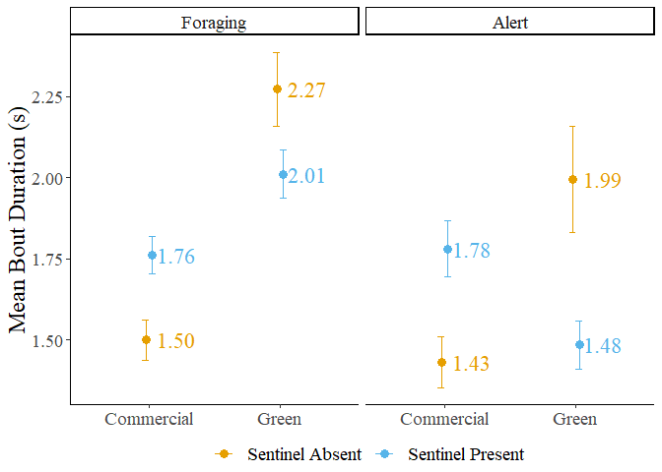
Figure 3.3: Mean bout duration of foragers in commercial and green areas. The error bars represent the standard error.
Table 3.2: Results of the linear mixed models fit to the mean bout duration.
 | Bouts of all behaviours |  |  | Bouts of foraging behaviour |  |  | Bouts of alert behaviour
Predictors | Estimates | Std. Error | p | Estimates | Std. Error | p | Estimates | Std. Error | p
Intercept | 0.3330 | 0.1032 | 0.001 | 0.4370 | 0.0929 | <0.001 | 0.0165 | 0.1530 | 0.914
Sentinel Presence | 0.1974 | 0.0720 | 0.006 | 0.0919 | 0.0718 | 0.201 | 0.1480 | 0.1005 | 0.141
Generalized Environment | 0.3534 | 0.0873 | <0.001 | 0.3826 | 0.0778 | <0.001 | 0.1619 | 0.1258 | 0.198
Group Size | -0.0046 | 0.0766 | 0.952 | -0.1519 | 0.0684 | 0.026 | 0.1057 | 0.1186 | 0.373
Bait Presence | -0.1430 | 0.0760 | 0.060 | -0.1385 | 0.0697 | 0.047 | -0.1378 | 0.1180 | 0.243
Disturbance Frequency | -0.0878 | 0.0295 | 0.003 | -0.1075 | 0.0301 | <0.001 | -0.0624 | 0.0453 | 0.169
Sentinel Presence: Generalized Environment | -0.2524 | 0.0882 | 0.004 | -0.2272 | 0.0914 | 0.013 | -0.2736 | 0.1352 | 0.043
Behaviour | -0.2557 | 0.0511 | <0.001
Behaviour: Sentinel Presence | -0.0810 | 0.0563 | 0.150
Behaviour: Generalized Environment | -0.2023 | 0.0537 | <0.001
Random Effects
σ² | 0.65 |  |  | 0.45 |  |  | 0.81
τ₀₀ | 0.03_{ID} |  |  | 0.01_{ID} |  |  | 0.07_{ID}
ICC | 0.04 |  |  | 0.03 |  |  | 0.08
N | 64_{ID} |  |  | 64_{ID} |  |  | 63_{ID}
Observations | 3897 |  |  | 1787 |  |  | 2110
Marginal R² / Conditional R² | 0.076 / 0.113 |  |  | 0.050 / 0.075 |  |  | 0.011 / 0.086

p = 0.026; Table 3.2). Bouts of foraging behaviour were significantly shorter in the presence of bait ($\hat{β}$ = -0.139, SE = 0.070, t = -1.989, p = 0.047; Table 3.2). The duration of bouts of foraging significantly decreased as disturbance frequency increased ($\hat{β}$ = -0.108, SE = 0.030, t = -3.566, p = <0.001, Table 3.2). We found a significant interaction between generalized environment and sentinel presence ($\hat{β}$ = -0.227, SE = 0.091, t = -2.485, p = 0.013; Figure 3.3, Table 3.2). Post hoc tests showed significant differences in the duration of bouts of foraging behaviour. In the absence of a sentinel, foragers in green areas had significantly longer bouts of foraging behaviour than in commercial areas ($\hat{β}$ = -0.383, SE = 0.078, z-ratio = -4.919, p < 0.001). In the presence of a sentinel, foragers in green areas also had significantly longer bouts of foraging behaviour than in commercial areas ($\hat{β}$ = -0.156, SE = 0.067, z-ratio = -2.337, p = 0.029). In green areas, foragers in the presence of a sentinel had marginally shorter bouts of foraging behaviour than in the absence of a sentinel ($\hat{β}$ = 0.135, SE = 0.068, z-ratio = 1.977, p = 0.058).

Duration of bouts of “alert” behaviour
Sentinel behaviour, generalized environment, group size, bait presence and disturbance frequency had no significant effect on the duration of bouts of alert behaviour (p > 0.05; Table 3.2). We found a significant interaction between sentinel behaviour and generalized environment ($\hat{β}$ = -0.274, SE = 0.135, t = -2.024, p = 0.043; Figure 3.3, Table 3.2). Post hoc pairwise t-tests revealed no significant differences in the duration of bouts of alert behaviour.
The duration of bouts of alert behaviour were not affected by recurrent, baited sampling ($\hat{β}$ = -0.009, SE = 0.007, t = -1.230, p = 0.198), suggesting little effect of habituation on the alertness of individuals in the recurrent sampling location.

Discussion
We investigated if the presence of a sentinel and the type of environment affected the behaviour of foraging American crows. We predicted that in the presence of a sentinel the individual vigilance of crow foragers would decrease and that this effect would be stronger in green areas where reduced ambient noise and longer lines of sight would make a sentinel more effective. We found that sentinel presence alone had no significant effects on the behaviour of foragers apart from the duration of all behaviours were significantly higher in the presence of a sentinel. We did observe a significant interaction between sentinel presence and generalized environment on the duration of bouts of foraging and alert behaviour. This suggests that the benefits of sentinel coverage are affected by the type of foraging environment, and that foragers will rely more on sentinels when their coverage is most effective. We found that the generalized environment had a significant effect on forager behaviour, with foragers in green areas having longer bouts of foraging behaviour. This suggests that crows need to spend more time being vulnerable to search for food items. The increased vulnerability, and therefore risk, could be traded off for increased likelihood of finding higher quality food items. Overall, our results do not fully support our initial hypotheses and suggest that sentinel behaviour and forager behaviour in crows could be influenced by complex interactions between individual factors and forager’s perception of the safety in their environment. Additional factors, such as group composition, could likewise affect foraging behaviour, with the presence of juveniles potentially increasing the vigilance of adults (Santema and Clutton-Brock 2013).

The effects of sentinel presence on forager behaviour
Our results contrast with previous studies that found that the presence of a sentinel led to a decrease in alert behaviour (Hollén et al. 2008; Ridley et al. 2014). Pied babblers (Turdoides bicolor) increase the proportion of time spent foraging after the start of a sentinel bout and had increased biomass intake (Hollén et al. 2008). In our case, American crows did not appear to alter their alert or foraging behaviour in response to sentinel presence alone. Instead, sentinel coverage appears to be most effective in green areas, as we saw a decrease in the duration of bouts of alert behaviour, and an increase in the duration of bouts of foraging behaviour. The significant interaction between sentinel presence and generalized environment shows that the comparatively busier and noisier commercial areas can potentially make sentinel-forager communication more difficult. This could result in decreased reliance on sentinel coverage, and greater individual vigilance in foragers. In the absence of a sentinel, foragers in green areas appear to have comparatively longer bouts of alert and foraging behaviour though these differences were not significant. This increase could potentially be the result of increased reliance on some form of coordination of vigilance between foragers, with longer but fewer bouts of alert behaviour. Whether crows have ground-level coordination of vigilance, and how they could be switching between reliance on the sentinel and reliance on ground-level vigilance, is an interesting topic for future research.
Foragers in commercial areas and in the absence of a sentinel do not appear to rely on other group members, as the duration of their bouts of alert and foraging behaviour are similar, and short. Foraging crows could be devoting as little time as possible to each behaviour to decrease the duration time spent on the ground where the risk is greatest. In the presence of a sentinel, foragers in commercial areas appear to have slightly longer bouts of alert and foraging behaviour than in the absence of a sentinel, although this comparison was not significant in our post-hoc tests. Though potentially impaired by ambient noise, sentinels in commercial areas could inform the foragers of more dangerous disturbances (e.g. raptors, humans), potentially resulting in the longer bouts of foraging behaviour. As for the increased duration of alert behaviour, foragers in the absence of a sentinel could elect to immediately take flight when disturbed, while foragers in the presence of a sentinel could have longer to decide whether to stay or flee.
The benefits of sentinel behaviour can be more subtle or indirect than initially thought, such as providing a greater sense of security that allows foragers to focus more on foraging without actively reducing their vigilance (Hollén et al. 2008). The proportion of time allocated to alert behaviour might also be used to scan for foraging patches and other foragers, explaining the absence of effects of sentinel presence on the proportion of time spent being alert. Foragers could also benefit from sentinel presence by increasing the distance between foragers, permitting the group to forage over a greater surface area while compensating for the increased predation risk from foraging further apart (Hollén et al. 2008). Sentinel behaviour could therefore compensate for riskier group-foraging strategies, not only individual changes in behaviour. This suggests the relationship between sentinels and foragers could be more complex, reinforcing the importance of considering individual differences and motivations when studying social behaviours. The presence of juveniles in the foraging group could also affect how group members forage and is an important aspect to consider in future studies.

Effects of foraging in commercial vs green areas
We found that the generalized environment had significant effects on forager behaviour, with significantly longer bouts of foraging observed in green areas. The increased duration of bouts of foraging behaviour suggests that foraging in green areas takes longer. Vegetation might obscure food items, making them harder to spot and, in the case of prey, harder to catch. Additionally, food patches could be dispersed over a greater area, requiring more time to search for. This was observed in the decreased duration of foraging bouts in the presence of bait, a proxy for human litter. Our results suggest that foraging on bait or litter could be quicker and decrease time being vulnerable when compared to foraging on natural food patches. The lack of significant effects of sampling effort in the baited, recurrent sampling location could suggest that American crows are not habituating but are habituated to this type of food source.
Green areas, such as parks, offer longer lines of sight and less ambient noise which makes the sentinel more effective (Hollén et al. 2011) but could also benefit urban raptors. Urban red-tailed hawk (Buteo jamaicensis) populations make large green areas the cores of their home ranges (Morrison et al. 2016). Foraging in green areas could therefore be risky, explaining an individual’s need to maintain vigilance. Higher disturbance frequency, regardless of area type, led to a decrease in the duration of bouts of all behaviours, particularly foraging. American crows could be decreasing the duration of bouts of foraging behaviour to minimize their exposure to perceived threats. Areas with higher disturbance frequencies typically had a greater frequency of vehicular disturbances, which American crows could be more tolerant of (Mukherjee et al. 2013). Though not formally quantified, we did observe foraging crows abandon sites when disturbed by raptors but only temporarily flee when disturbed by vehicles. This suggests that the type of disturbances in each environment could change how risky an environment is to forage on and adds another layer of complexity when comparing different areas within a city.
We observed shorter bouts of foraging behaviour in commercial areas. Food scraps and litter in commercial areas are considerably easier to find when on impermeable surfaces, reducing the time to find and catch food. The decreased duration of bouts of foraging behaviour in the presence of bait, regardless of environment, supports this hypothesis. In green and commercial areas, bait was dropped on an impermeable surface, mimicking human litter. The ease of foraging on anthropogenic foods could explain the shift in preference observed in many urban species. Moreover, anthropogenic foods can have a greater caloric content than non-anthropogenic foods, making them more satiating than other food sources, likely playing a role in the shift in their foraging preferences for anthropogenic foods (Marzluff et al. 2001; Marzluff and Neatherlin 2006).
The absence of effect of generalized environment on the likelihood of a sentinel being present in our videos is not necessarily unexpected. Bedneckoff's state-dependent model states that individuals make decisions based on their own energetic needs and the benefits they receive (Bednekoff 1997). An individual with sufficient energetic reserves could decide to perform sentinel behaviour as a safer option if the alternative is foraging without a sentinel. In urban areas, the presence of anthropogenic food could facilitate the replenishment of energetic reserves. As a result, individuals might be more likely to engage in sentinel behaviour and increase their sentinel efforts, either by increasing frequency and/or duration of behaviour bouts. In our case, all individuals are urban and can move between environments within the urban area. If travel time or time between foraging events is short, individuals could then be able to immediately sentinel upon arriving at a foraging site. Unfortunately, we were unable to track crow movements within a city to test this hypothesis, but it would be an interesting avenue for future research.

Group Size
As group size increased, the duration of bouts of foraging behaviour increased but was not associated with a decrease in the duration of bouts of alert behaviour. The proportion of time allocated to either behaviour was also unchanged by the size of the group. This finding is surprising, as previous studies suggest that larger group sizes should decrease individual vigilance while increasing foraging efficiency (Lima 1995; Ward and Low 1997; Beauchamp 2008, 2013), yet the effect of group size was only observed in the duration of bouts of foraging behaviour. Bouts of alert behaviour could have a minimal duration to effectively monitor the surrounding environment for sources of threat. Alternatively, the bouts of alert behaviour be used to also maintain awareness of other group members due to the increased competition for resources in larger groups. Instead of only looking out for sources of threat, foragers could be looking at the behaviour of other group members in case they found a better patch to forage on.

Future directions and improvements
Our study has several limitations that should be acknowledged. Our sample size could have limited the ability to detect more subtle effects. As such, caution should be exercised when interpreting the results, and future studies should build upon our preliminary findings using long-term video recorders and sampling locations across a wider breadth of urbanization. Additionally, the study focused on the population of crows in St. Catharines Ontario, which could limit the generalizability of our results to other populations or environments. Factors such as local food availability, the number and area of green spaces, and predator presence can vary widely between cities, and these factors can affect the behaviour of foraging crows. Therefore, the findings of our study could differ from those of a similar study performed in a different city.
Our study investigated the effects of sentinel behaviour and the generalized environment on the behaviour of foraging American crows in urban environments. Contrary to expectations, sentinel presence did not have a significant effect on forager behaviour. The generalized environment, however, had a significant impact on forager behaviour. Crows in green areas exhibited longer bouts of foraging behaviour and more transitions from the vulnerable to the alert state compared to those in commercial areas. Crows therefore alter their foraging behaviour in response to changes in environmental factors such as resource distribution and predation risk. A significant interaction between sentinel presence and generalized environment was also observed, suggesting that the effectiveness of the sentinel might differ between environments. This is reflected in an increased reliance on the sentinel in foragers in green areas, where the sentinel’s effectiveness is greatest.
These findings have several implications for understanding crow behaviour. They suggest that crows can adapt their behaviour based on environmental conditions and individual needs. The lack of significant effects of sentinel behaviour points towards the complexity of social behaviour in crows and the importance of considering individual variation in decision-making. Overall, the study provides valuable insights into the factors influencing crow behaviour in urban environments and highlights the need for further research to fully understand these complex behaviours.

References
Aronson MFJ, La Sorte FA, Nilon CH, et al (2014) A global analysis of the impacts of urbanization on bird and plant diversity reveals key anthropogenic drivers. Proceedings of the Royal Society B: Biological Sciences 281:20133330. https://doi.org/10.1098/rspb.2013.3330
Auman HJ, Meathrel CE, Richardson A (2008) Supersize me: does anthropogenic food change the body condition of silver gulls? A comparison between urbanized and remote, non-urbanized areas. Waterbirds 31:122–126
Beauchamp G (2013) Social predation: how group living benefits predators and prey. Elsevier
Beauchamp G (2008) What is the magnitude of the group-size effect on vigilance? Behavioral Ecology 19:1361–1368. https://doi.org/10.1093/beheco/arn096
Bednekoff PA (2015) Sentinel behavior: a review and prospectus. In: Advances in the Study of Behavior. Elsevier, pp 115–145
Bednekoff PA (1997) Mutualism among safe, selfish sentinels: a dynamic game. The American Naturalist 150:373–392. https://doi.org/10.1086/286070
Benmazouz I, Jokimäki J, Lengyel S, et al (2021) Corvids in urban environments: a systematic global literature review. Animals : an Open Access Journal from MDPI 11:3226. https://doi.org/10.3390/ani11113226
Donihue CM, Lambert MR (2015) Adaptive evolution in urban ecosystems. Ambio 44:194–203. https://doi.org/10.1007/s13280-014-0547-2
Friard O, Gamba M (2016) BORIS: a free, versatile open-source event-logging software for video/audio coding and live observations. Methods in Ecology and Evolution 7:1325–1330. https://doi.org/10.1111/2041-210X.12584
Hollén LI, Bell MBV, Radford AN (2008) Cooperative sentinel calling? Foragers gain increased biomass intake. Current Biology 18:576–579. https://doi.org/10.1016/j.cub.2008.02.078
Hollén LI, Bell MBV, Wade HM, et al (2011) Ecological conditions influence sentinel decisions. Animal Behaviour 82:1435–1441. https://doi.org/10.1016/j.anbehav.2011.09.028
Isaksson C (2018) Impact of urbanization on birds. In: Tietze DT (ed) Bird Species: How They Arise, Modify and Vanish. Springer International Publishing, Cham, pp 235–257
Kern JM, Radford AN (2016) Anthropogenic noise disrupts use of vocal information about predation risk. Environ Pollut 218:988–995. https://doi.org/10.1016/j.envpol.2016.08.049
Koller M (2016) Robustlmm: an R package for robust estimation of linear mixed-effects models. Journal of Statistical Software 75:1–24. https://doi.org/10.18637/jss.v075.i06
Lima SL (1995) Back to the basics of anti-predatory vigilance: the group-size effect. Animal Behaviour 49:11–20. https://doi.org/10.1016/0003-3472(95)80149-9
Łopucki R, Klich D, Kiersztyn A (2021) Changes in the social behavior of urban animals: more aggression or tolerance? Mamm Biol 101:1–10. https://doi.org/10.1007/s42991-020-00075-1
Lowry H, Lill A, Wong BBM (2013) Behavioural responses of wildlife to urban environments. Biological reviews of the Cambridge Philosophical Society 88:537–549. https://doi.org/10.1111/brv.12012
Marzluff JM, McGowan KJ, Donnelly R, Knight RL (2001) Causes and consequences of expanding American crow populations. In: Marzluff JM, Bowman R, Donnelly R (eds) Avian Ecology and Conservation in an Urbanizing World. Springer US, Boston, MA, pp 331–363
Marzluff JM, Neatherlin E (2006) Corvid response to human settlements and campgrounds: Causes, consequences, and challenges for conservation. Biological conservation 130:301–314. https://doi.org/10.1016/j.biocon.2005.12.026
Morrison JL, Gottlieb IGW, Pias KE (2016) Spatial distribution and the value of green spaces for urban red-tailed hawks. Urban Ecosyst 19:1373–1388. https://doi.org/10.1007/s11252-016-0554-0
Mukherjee S, Ray-Mukherjee J, Sarabia R (2013) Behaviour of American Crows (Corvus brachyrhynchos) when encountering an oncoming vehicle. Can Field Nat 127:229. https://doi.org/10.22621/cfn.v127i3.1488
R Core Team (2022) R: the R project for statistical computing
Ridley AR, Raihani NJ, Bell MBV (2010) Experimental evidence that sentinel behaviour is affected by risk. Biology Letters 6:445–448. https://doi.org/10.1098/rsbl.2010.0023
Ridley AR, Wiley EM, Thompson AM (2014) The ecological benefits of interceptive eavesdropping. Funct Ecol 28:197–205. https://doi.org/10.1111/1365-2435.12153
Santema P, Clutton-Brock T (2013) Meerkat helpers increase sentinel behaviour and bipedal vigilance in the presence of pups. Animal Behaviour 85:655–661. https://doi.org/10.1016/j.anbehav.2012.12.029
UN Department of Economic and Social Affairs (2018) 68% of the world population projected to live in urban areas by 2050, says UN. In: United Nations. https://www.un.org/development/desa/en/news/population/2018-revision-of-world-urbanization-prospects.html
Ward C, Low BS (1997) Predictors of vigilance for american crows foraging in an urban environment. The Wilson Bulletin 109:481–489
Withey JC, Marzluff JM (2009) Multi-scale use of lands providing anthropogenic resources by American Crows in an urbanizing landscape. Landscape Ecol 24:281–293. https://doi.org/10.1007/s10980-008-9305-9

